**School Management Tool**

**A PROJECT REPORT**

***Submitted by***

# Bhavsar Rajkumar Jiteshbhai

**190843131001**

***In fulfilment for the award of the degree***

***of***

# BACHELOR OF ENGINEERING

### in

**Computer Science Engineering**

**R.N.G PATEL INSTITUTE OF TECHNOLOGY - RNGPIT**

**ISROLI (BARDOLI)**



# Gujarat Technological University, Ahmedabad

**April - May, 2022**





**R. N. G. Patel Institute of Technology, Bardoli – Navsari Road,**

**At: Isroli (Tajpore) PO: Afwa  
Tal: Bardoli – 394620**

**CERTIFICATE**

Date:

This is to certify that the Project report submitted along with the project entitled **School Management Tool** has been carried out by **Bhavsar Rajkumar Jiteshbhai** (**190843131001)** for subject Internship (Subject Code:3180701) under my guidance in fulfilment of the degree of Bachelor of Engineering in Computer (8th Semester) of Gujarat Technological University, Ahmadabad during the academic year 2021-22.

Mr. Vivek C. Joshi Dr. Madhavi B. Desai

Internal Guide Head of the Department

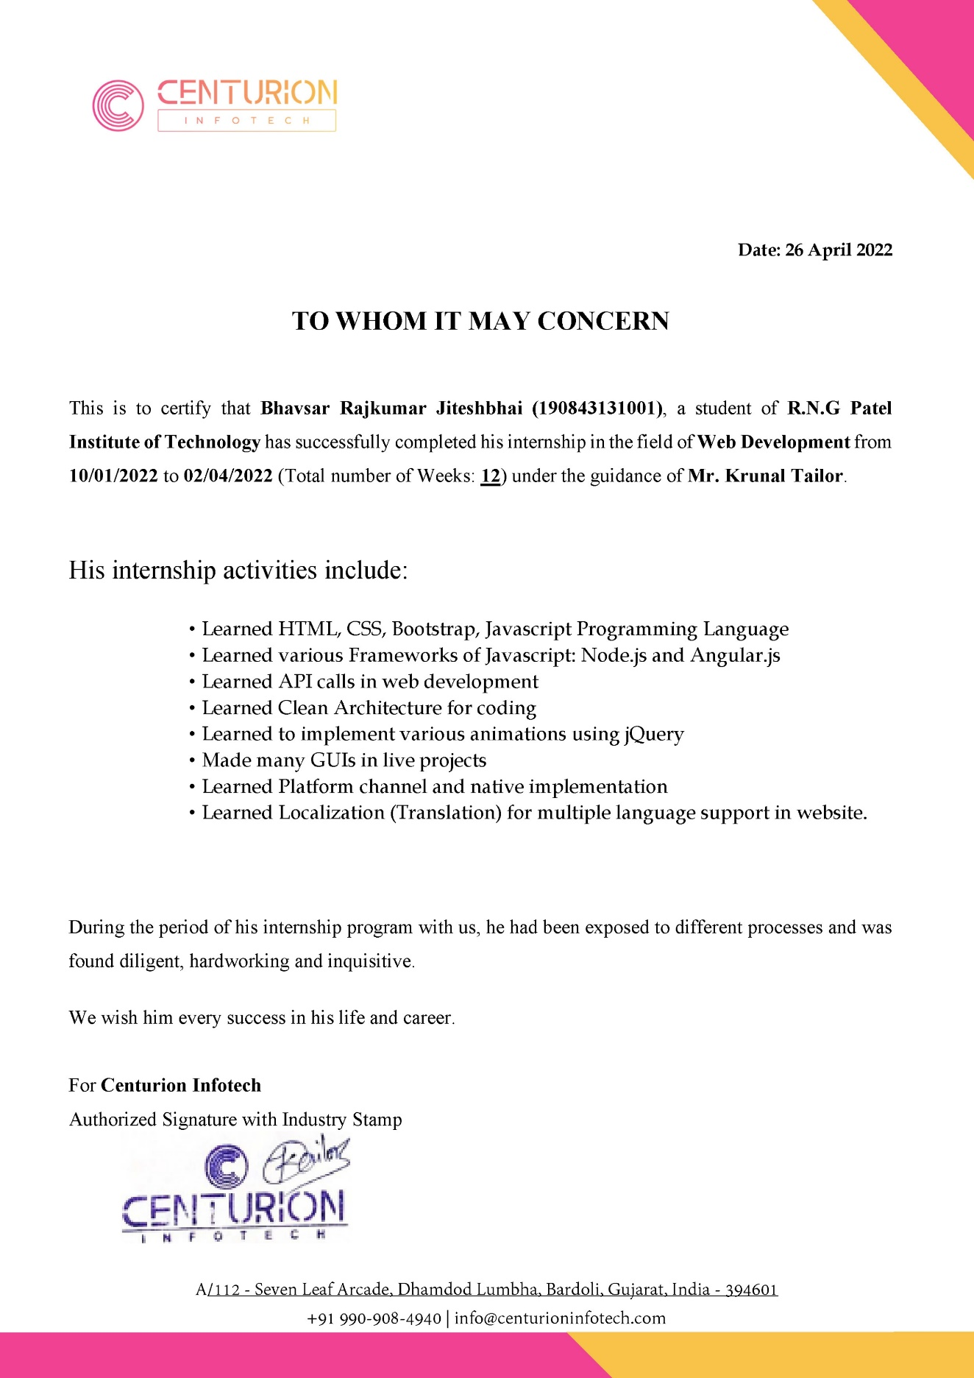

 

**R. N. G. Patel Institute of Technology, Bardoli – Navsari Road,**

**At: Isroli (Tajpore) PO: Afwa  
Tal: Bardoli – 394620**

**DECLARATION**

We hereby declare that the Internship report submitted along with the Project entitled **Warehouse Management** submitted in partial fulfilment for the degree of Bachelor of Engineering in Computer Science to Gujarat Technological University, Ahmedabad, is a bonafide record of original project work carried out by me at **R. N. G. Patel Institute Of Technology** under the supervision of **Mr. Vivek C. Joshi** and that no part of this report has been directly copied from any students’ reports or taken from any other source, without providing due reference.

Name of the Student Sign of Student

Pansuriya Darshil Jaysukhbhai ______________________

**ACKNOWLEDGEMENT**

The satisfaction that accompanies the successful completion of this internship would be incomplete without mentioning the people who made it possible, without whose constant guidance and encouragement would have made efforts go in vain. I consider myself privileged to express gratitude and respect towards all those who has guided through the completion of projects.

I extend my deepest gratitude to my mentor **Mr. Vivek C. Joshi** for guiding, supporting and helping me in every possible way.

During my internship, My supervisor **Ms. Priyanka Rajani** from Infozium Solution PVT. LTD. was very helpful and extended his valuable guidance and provide help whenever required.

I am grateful to **Dr. Madhavi Desai**, Head of the Department, Computer Science & Engineering, RNGPIT for giving us the support and encouragement that was necessary for the completion of this internship.

I would also like to express my deepest gratitude to **Dr. Latesh Chaudhari**, Principal of R. N. G. Patel Institute of Technology for providing us congenial environment to work in.

I would also like to thank Placement Cell of the department for giving me an opportunity to be the part of this internship. I extend my gratitude to all the faculty members for their understanding and guidance that gave me strength to work to long hours for developing a project and preparing the report.

**Pansuriya Darshil Jaysukhbhai (180840131033)**

**Abstract**

Back-End Development is key part of web applications and softwares . My internship was on Node JS Technology. During Internship learning a lot from my senior and perform many tasks which is given by team Leader. Working on different different APIs for the learning purpose. Learning Node Js from various sources like Udemy, YouTube and blogs which are helping me for increase my knowledge. During internship gain the knowledge of relational database is MySQL and non-relational Database MongoDB. Worked on the warehouse management project which is client’s project. From this project I learn about the how the particular system being develop and manage in the industry, also learn how to give the demo to the client and deal with client.

**List of Figures**

Fig 5.1 Use case Diagram .................................................................................................. 10

Fig 5.2 Activity Diagaram ................................................................................................ 11

Fig 6.3.1 Folder structure of Project …….......................................................................... 13

Fig 6.3.2 Admin create manager and delivery person........................................................ 13

Fig 6.3.3 Admin can block Manager ................................................................................. 14

Fig 6.3.4 Admin view list of all manager………................................................................ 14

Fig 6.3.5 Manager can not login…………………............................................................. 15

Fig 6.3.6 Upload excel file…………………...................................................................... 15

Fig 6.3.7 Manager assign Order………………................................................................. 16

Fig 6.3.8 Order of Delivery Person……………................................................................. 16

Fig 6.3.9 Update the Status of Order……….……............................................................. 17

Fig 6.3.10 Delivery person wise order……....................................................................... 17

Fig 6.3.11 History of orders for delivery person……….................................................... 18

Fig 6.3.12 Cash collection of delivery person………….................................................... 18

Fig 6.3.13 Database…………………………………….................................................... 19

Fig 6.3.14 View Reports……………………………….................................................... 19

Fig 6.3.15 Project Code-1……………………………….................................................. 20

Fig 6.3.16 Project Code-2…………………...................................................................... 20

**List of Tables**

Table 3.7.1 During January ............................................................................................. 33

Table 3.7.2 During February ........................................................................................... 34

Table 3.7.3 During March ............................................................................................... 34

Table 5.3.1 Sale Table …................................................................................................. 34

Table 3.7.3 Warehouse Table .......................................................................................... 34

Table 3.7.3 Manager Table.............................................................................................. 34

Table 3.7.3 Delivery Person Table .................................................................................. 34

**Abbreviations**

UI User Interface

QA Quality Assurance

API Application Programming Interface

JS Javascript

**Table of Contents**

Acknowledgment............................................................................................................... i

Abstract.............................................................................................................................. ii

List of Figures.................................................................................................................... iii

List of Tables ..................................................................................................................... v

List of Abbreviations ........................................................................................................ vi

Table of Contents.............................................................................................................. vii

**Chapter 1 Overview of the Company............................................................................. 1**

1.1 History of the Company.............................................................................................. 1

1.2 Scope of work………………………………………….…………………………… 1

1.3 More About Company’s Information…………………..………………………....... 2

1.4 Company Vision…………………...………………………….………………......... 2

1.5 Company Objective …………………………………..………………………......... 2

**Chapter 2 Overview of different department of the organization and Layout of the Production/process being carried out in company**......................................................... 3

2.1 Departments ………………………………………………………………............... 3

2.1.1 Mobile Application Department........................................................................... 4

2.1.2 Web Application Department............................................................................... 4

2.1.3 Game Department………..................................................................................... 4

2.2 Steps to complete a project…………………………………………………............. 3

2.3 Sequence of operation ….……………………………………………....….............. 3

**Chapter 3 Introduction to Internship and Project……..……………………….…….. 4**

3.1 Internship Summary ................................................................................................... 4

3.2 Purpose Of Internship……...…………………………..…………………...……..... 4

3.3 Objective Of Internship……………...……………………………..………..……… 5

3.4 Scope Of Internship…...…………………………………………………………..... 5

3.5 Technology and Literature review ……………………………………..……..……. 5

3.5.1 Node JS …..……………………………………………………..………...……. 5

3.5.2 MySQl…..………………………………………………………………...…..... 6

3.6 Internship Planning …………………………………………………………..…...... 7

3.6.1 Project Development Approach ………………………………………..……..... 7

3.6.2 Roles & Responsibilities ……………………………………………….……..... 7

3.7 Internship and Project scheduling ………………………………………..…………. 7

**Chapter 4 System Analysis** …………………………………………………………....... 8

4.1 Case Study of current system……………………………………………………….. 8

4.2 Problems of current system ……………………………………………………..….. 8

4.3 Requirement of new system ……………………………………………………….. 8

4.4 System Feasibility …….……………………………………………………………. 8

4.5 Process of new system …..………………………………………………………….. 9

4.6 Features of new system ………………….………………………………………..... 9

4.7 Selection of software and justification …..………………………………………..... 9

**Chapter 5 System Design ……………………………………………………………… 10**

5.1 Use case Diagram ………………………………………………………………..... 10

5.2 Activity Diagram ………………………………………………………………….. 11

5.2 Database Design .………………………………………………………………….. 11

**Chapter 6 Implementation …………………………………………………………….. 12**

6.1 Implementation Platform ………………………………………..………………… 12

6.2 Module Specification …………………………………………………………........ 12

6.2.1 Admin Manages Manager and Delivery Person ……………………..…..……. 12

6.2.2 Manager can Upload Order and assign .………………………………………. 12

6.2.3 Admin and Manager can view reports of order…..……………………………. 12

6.3 Snapshots ...…………………………………………………………………........... 13

**Chapter 7 Testing …………………………………………………………………........ 33**

7.1 Testing Plan ...…………………………………………………………………....... 33

7.2 Test Result and Analysis ………………………………………………………....... 33

**Chapter 8 Conclusion & Discussion……………………………………………...……. 35**

8.1 Overall Analysis of Internship …...…………………………………………...…… 35

8.2 Dates of Continuous Evaluation……………………………………………..…….. 35

8.3 Problems encountered and possible solution …….……………………….....…….. 35

8.4 Internship summary ……………………………………………………………….. 35

8.5 Limitations and Future Enhancement ………………………………………........... 36

8.6 References ………………………….………………………………………........... 36

Appendix …....................................................................................................................... 38

**Chapter: 1 OVERVIEW OF THE COMPANY**

* 1. **History**

Started Since 2011, our Co-Founder Mr. Mitesh Lathiya left his high-paying job and took a risk & loan of 2 lakh Rupees to launch the Start-Up called Infinity, an I.T. services provider for few selected Indian & International clients. In 2014 Initial development & exposure stage provided the team enthusiasm & credibility to develop their own products and rename Infinity as PistaLix!. In 2017 With additional convenience, vital technical assistance, and comprehensive services, we have succeeded and decided to change the Pistalix solution to InFoZium.

* 1. **SCOPE OF WORK**

Company have mainly 3 teams and first is Infizius which is provide mobile application service over the world wide and second is Xtripo travel which is companies own product it’s basically ERP for business and third is Playmax gaming which is provides gaming solution and create multiple games delivery to clients. Apart from these company is working on more own products for mobile and web.

**1.3 More About Company’s Information**

The Infozium Group has established itself as one of the most sought-after technology partners in a variety of industries, especially in the context of digital transformation. By offering the best in our field, we have extended our Infozium Group in 3 different areas. We have a long-standing client who has been with us for many years, and our success is shown in our consistent and steady expansion of firms.

Achievements of Company :-

* Xtripo achieved IATA certification and Startupindia certification, a remarkable success within small time.
* Certificate of Accreditation By Infozium Solution PVT LTD.

**1.4** **Company Vision**

Creating young Zinius for delivering futuristic growth with infinite technology services & solutions. The Infozium Group is to achieve our group revenue of 1000 crores and group net valuation of 5000 crores by 2025 through supporting our clients with technical services & solutions beyond their expectations.

**1.5 Company Objective**

Clear standards and trust-based relationships are important to us since they enable us to enhance delighted customers and employees. By continues, collaboration with the customer helps us to deliver innovative & customer-centric solutions on time. Always Make Client happy with Satisfactory project delivery and give some extra benefits over the delivery of product make client more happy and growth the company revenue and market. Working on more companies products which are solve the B2B Business problems with create multiple platform application and website.

**CHAPTER:2 OVERVIEW OF DIFFERENT DEPARTMENT OF THE ORGANIZATION AND LAYOUT OF THE PRODUCTION/PROCESS BEING CARRIED OUT IN COMPANY**

**2.1 Departments**

At our company there are Many departments.

* Mobile Application Department - Infizius Team
* Web Applications Department - Xtripo Travel Team
* Gaming Department - Playmax Gaming Team
* Marketing Team – BDM Team

**2.1.1 Mobile Application Department**

We provide a comprehensive solution and everything you need to develop your own mobile app (Android & iOS) without any coding knowledge! Infizius has extensive experience developing high-performing, digitally transformational, and feature-rich mobile apps for all major mobile platforms. It doesn’t matter if it’s an Apple, Android, or hybrid device. We have digital Einstein developers who can construct dynamic, high-quality mobile apps for a variety of platforms. All you have to do now is pick from our collection of high-quality, ready-to-use web & app templates and let our team of experts handle the rest.

**2.1.2 Web Applications Department**

Xtripo has revolutionized the travel industry. We tailor end-to-end travel services, such as selecting and arranging acceptable flights before moving on to hotel stays. We have dominant hotel affiliations all over the world, allowing us to give the best value for our customers’ money. We have a skilled team that will respond to your questions as quickly as possible. Our staff will research the greatest vacation packages available, sort through cruise packages, and complete your entire trip in one go.

**2.1.3 Game Department**

Playmax Gaming is one of the world’s fastest-growing game development company. As a leading game design and development firm, Playmax can be your one-stop shop for all of your game development needs. Among the services we provide are conception enhancement, character customization, graphics and animation, game mechanics, coding, and testing.

**2.2 Steps to Complete a Project**

Most of the time company is using Automatic scanning tools for the small size of the project, but when the project is at large scale, company use agile methodology. Company is mainly focus on the deadline achievement. Our first priority when a project is assigned is that to complete the task in a given time and weeks.

**2.3 Sequence of Operation**

Requirement analysis is the most important and fundamental stage in Application Testing. It is performed by the senior members of the team with inputs from the hackers, the sales department, market surveys and domain experts in the industry. This information is then used to plan the basic project approach and to conduct product feasibility study in the economical, operational and technical areas.

Planning for the quality assurance requirements and identification of the risks associated with the project is also done in the planning stage.

After successfully complete security testing face they generate report bas on application testing. Send that report to that client and explain about web applications weakness and it’s bad impact. The outcome of the technical feasibility study is to define the various technical approaches that can be followed to implement the project successfully with minimum risks.

**Chapter: 3 INTRODUCTION TO INTERNSHIP AND PROJECT**

The internship program is designed to provide students engaged in a field experience with an opportunity to share their insights, to explore the links between students' academic preparation and their field work, and to assist participants in developing and carrying out the major research project which will serve to culminate their internship experience.

Internships are individualized and tailored to the needs and interests of each student in the program. As part of the internship experience, students are expected to take an active role in finding an appropriate internship for themselves. Many students pursue their own contacts, however, information is available on Locating Internship Sites.

**3.1 Internship Summary**

To experience the practical working of what we studied in the book theories, is very interesting, memorable and very important in our education. Doing internship is my first experience of working for any company and learn how the things are being done in the actual industry. It was very memorable and everlasting experience of doing an internship. I have done internship in Evolution info secure, Surat. It was 12 weeks long.

My Internship was excellent with full of hands on Experience. Learning a lot from the leader and company work culture how to deal with client and how to structure project. In Starting weeks Learning Node Js course from Udemy. Create Multiple APIs in Nodejs for learning purpose and worked on the warehouse management project. Overall Experience was Good learn and solve a lot’s from Real world problem and Projects solution.

**3.2 Purpose of Internship**

* Main Purpose of an Internship that I wanted to learn new technologies which are use by the companies Nowadays and the real or hands on work within the company and team.
* Internship is good things though which a we can see how Actual or Real work done in companies and what are client requirement and how to deal with them it’s a good experience that I want to pursue during Internship Period.
* My believe that Internship or Training and learn from Expert make growth success and under the work in senior developer will teach us to solving any kind of project and solution of any problem that I want to learn from Internship.

**3.3 Objective Of Internship**

* Apply skill concepts and theories to real-world decision-making
* Increase knowledge in are such as operations management, Website design and development , provide creative solution to client.
* Develop and improve skills in communication, technology, quantitative reasoning, and teamwork.
* Observe and participate in operations and decision-making will make confidence and Interest .
* Meet professional role models and potential mentors who can provide guidance, feedback, and support.
* Expand network of professional relationships and contacts.

**3.4 Scope of Internship**

* Gain knowledge from Internship and Industry Experts.
* An Internship Provides Real Life Experience and Exposure.
* Deal with Clients and find Solution of any project
* Get Connected and Develop Your Professional Network
* The Opportunity To Learn More About Yourself

**3.5** **TECHNOLOGY AND LITERATURE REVIEW**

**3.5.1 Node JS**

Features of Node.js:

Following are some of the important features that make Node.js the first choice of software architects.

* Asynchronous and Event Driven − All APIs of Node.js library is asynchronous, that is, non-blocking. It essentially means a Node.js based server never waits for an API to return data. The server moves to the next API after calling it and a notification mechanism of Events of Node.js helps the server to get a response from the previous API call.
* Very Fast − Being built on Google Chrome's V8 JavaScript Engine, Node.js library is very fast in code execution.
* Single Threaded but Highly Scalable − Node.js uses a single threaded model with event looping. Event mechanism helps the server to respond in a non-blocking way and makes the server highly scalable as opposed to traditional servers which create limited threads to handle requests. Node.js uses a single threaded program and the same program can provide service to a much larger number of requests than traditional servers like Apache HTTP Server.

**3.5.2 MySQL**

MySQL is an open-source relational database management system. As with other relational databases, MySQL stores data in tables made up of rows and columns. Users can define, manipulate, control, and query data using Structured Query Language, more commonly known as [SQL](https://www.digitalocean.com/community/tutorials/what-is-sql). It is used wisely in software development, Web application development and mobile application etc.

**3.6 INTERNSHIP PLANNING**

**3.6.1 PROJECT DEVELOPMENT APPROACH**

Agile Software Development is highly encouraged and followed for the development of all types of Products. This is because of the flexibility and low cost and fast delivery that it offers. For this project, we have selected to go Agile software development.

The Reason for selecting Agile Software development is that it will give us the flexibility to make changes as per client requests throughout the project at any time. It will also help to keep the development cost low after several changes also throughout the project.

**3.6.2 ROLES & RESPONSIBILITIES**

Roles: Trainee Back-End Developer

Responsibilities:

* Learn Node JS and practicing of different types of APIs.
* Build the APIs for the warehouse management project.
* Working with source code management using GIT, GITHUB, GITLAB.

**3.7 INTERNSHIP SCHEDULING**

Table 3.7.1 During January

|  |  |  |  |  |
| --- | --- | --- | --- | --- |
|  | Week-1 | Week-2 | Week-3 | Week-4 |
| Introduction of Company and Node JS |  |  |  |  |
| Node JS Training |  |  |  |  |
| Node JS Training and Implement Some Demo Tasks |  |  |  |  |
| Node JS and MySQL Training |  |  |  |  |

Table 3.7.2 During February

|  |  |  |  |  |
| --- | --- | --- | --- | --- |
|  | Week-1 | Week-2 | Week-3 | Week-4 |
| Research and started planning of warehouse project. |  |  |  |  |
| Starting Implementation of Warehouse Management project |  |  |  |  |
| Implement APIs on manager, Delivery person |  |  |  |  |

Table 3.7.3 During March

|  |  |  |  |  |
| --- | --- | --- | --- | --- |
|  | Week-1 | Week-2 | Week-3 | Week-4 |
| Implement APIs on Order in Warehouse Project |  |  |  |  |
| Implement Report APIs in Warehouse  Project |  |  |  |  |
| Started Working on battleship game project |  |  |  |  |
| Build APIs on battleship game project |  |  |  |  |

**Chapter 4: SYSTEM ANALYSIS**

**4.1 STUDY OF CURRENT SYSTEM**

Currently, the available system only contains a feature for management of educational organizations. It is really easy to manage an educational organization using SMT.

Currently, available systems also have limitations with APIs as the client haven’t provided us the dedicated API Server yet.

**4.2 PROBLEM OF CURRENT SYSTEM**

Currently, the system can be only used for educational domain. Additionally, the current systems have limitations, such as API calls for product. Also, the current system can be used in other domain such as E-Commerce with minimum number of changes to code.

**4.3 REQUIREMENT OF NEW SYSTEM**

The new system requires payment features and online homework available for both online and offline modes. Discounts should be calculated to promote digital payments.

In Covid Era, Education was one the sector that got hit the most. Using SMT it will be easier to continue education by online classes, online homework and online submission.

Students will be able to submit homework online and make fees payments through it on which they may also get some discounts.

**4.4 SYSTEM FEASIBILITY**

This system with the given requirements is possible to be implemented with the currently available technologies from cross-platform website/App to payment gateway. Few requirements like online fees payment with discounts can be implemented with few changes.

**4.5 PROCESS IN NEW SYSTEM**

The process of the new system starts with the organizational admin or principal creating an account in-web app and adding other teachers to the web app, and then the class teachers can start adding students of their respective classes for very first time. Then Teachers can use the feature to change classes so that they don’t have to again add all the students. Admin will be providing discounts coupons associated with them so students can pay fees using discount coupons. While making a payment students can select their respective class and enter the discount coupons to avail fees discounts. On the other side, Teachers can also arrange online class test, online homework submission, they can arrange annual exam online if required. Using online objective-based exam results can be provided speedily compared to conventional method.

**4.6 FEATURES OF NEW SYSTEM**

* Extra security options like password, passcode, or biometrics (in mobile application) over the traditional login/signup.
* Digital Fees Payment.
* Fees Discount Coupons.
* Online homework Submission.
* Time Saving Exams and Results.
* Transaction history.
* Exam/Test results history

**4.7** **SELECTION OF SOFTWARE AND JUSTIFICATION**

Angular [10] and Bootstrap [8] is selected for developing the frontend as it can easily develop web apps for cross-platform apps along with native functionality if required. Using Angular and Bootstrap, it is easy to maintain the web app as there is a single codebase for multiple browsers and operating systems. Beautiful UI can easily be made in Angular and Bootstrap with fast performance and better render time. For Cloud-services like API and storage, AWS is chosen as it has nearly 99% of Up-time with good maintenance and the cost will be as per our usage. The client hasn’t assigned the API Management Server Yet.

**CHAPTER 5: SYSTEM DESIGN**

**5.1 Usecase Diagram**

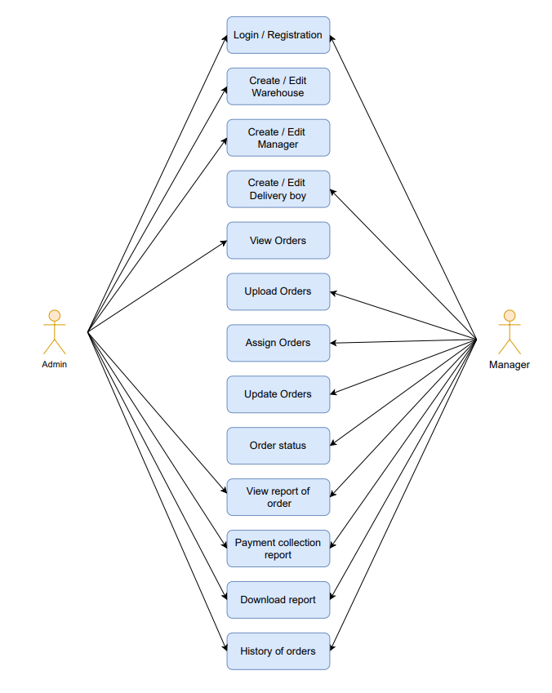

Fig 5.1 Use case Diagram

**5.2 Activity Diagram**

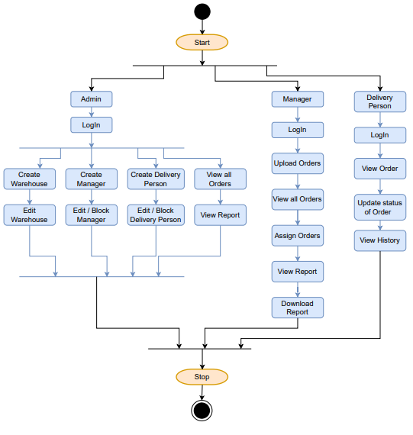

Fig 5.2 Activity Diagram

**5.3 Database Design**

Table 5.3.1 Sale Table

|  |  |  |  |  |
| --- | --- | --- | --- | --- |
| **Column Name** | **Data Type** | **Size** | **Constraint** | **Description** |
| sale_id | INT | N/A | Primary Key | Sale Id |
| order_id | VARCHAR | 20 | --- | Order Id |
| payment_type | ENUM | 20 | --- | Payment Type |
| grand_total | FLOAT | 10 | --- | Payment Amount |
| shipping_address | VARCHAR | 200 | --- | Shipping Address |
| awb_code | INT | N/A | --- | AWB Number |
| delivery_person_id | INT | N/A | --- | Delivery Person Id |
| manager_id | INT | N/A | --- | Manager Id |
| assign | BOOLEAN | N/A |  | Order assign or not |
| assign_date | DATE | N/A | --- | Order assign date |
| delivery_type | ENUM | N/A | --- | Delivery Type |
| delivery_status | ENUM | N/A | --- | Delivery Status |
| delivered_date | DATE | N/A | --- | Delivered Date |
| comments | VARCHAR | 100 | --- | Comments |

|  |  |  |  |  |
| --- | --- | --- | --- | --- |
| **Column Name** | **Data Type** | **Size** | **Constraint** | **Description** |
| warehouse_id | INT | N/A | Primary Key | Warehouse Id |
| warehouse_name | VARCHAR | 20 | --- | Warehouse Name |
| warehouse_location | VACHAR | 20 | --- | Warehouse Location |

Table 5.3.2 Warehouse Table

Table 5.3.3 Manager Table

|  |  |  |  |  |
| --- | --- | --- | --- | --- |
| **Column Name** | **Data Type** | **Size** | **Constraint** | **Description** |
| manager_id | INT | N/A | Primary Key | Warehouse Manager Id |
| name | VARCHAR | 20 | --- | Warehouse Manager Name |
| location | VARCHAR | 20 | --- | Warehouse Manager Location |
| email | VARCHAR | 20 | --- | Warehouse Manager Email |
| password | VARCHAR | 20 | --- | Warehouse Manager Password |
| Is_Active | BOOLEAN | N/A | --- | Active Or Not |
| warehouse_id | INT | N/A | Foreign Key | Warehouse Id |

Table 5.3.4 Delivery Person Table

|  |  |  |  |  |
| --- | --- | --- | --- | --- |
| **Column Name** | **Data Type** | **Size** | **Constraint** | **Description** |
| del_person_id | INT | N/A | Primary Key | Delivery Person Id |
| name | VARCHAR | 20 | --- | Delivery Person Name |
| location | VARCHAR | 20 | --- | Delivery Person Location |
| email | VARCHAR | 20 | --- | Delivery Person Email |
| password | VARCHAR | 20 | --- | Delivery Person Password |
| Is_Active | BOOLEAN | N/A | --- | Active Or Not |
| manager_id | INT | N/A | Foreign Key | Manager Id |

**CHAPTER 6: IMPLEMENTATION**

**6.1 IMPLEMENTATION PLATFORM**

This project is a web app-based systems so the following tools is used to develop the proposed application.

Tools and Platforms used to implement are:

* Visual Studio Code
* MySQL Workbench
* Postman

**6.2 MODULE SPECIFICATION**

I have been assigned to the following modules in this project:

**6.2.1 Admin Manages Warehouse Manager and Delivery Person**

In this module I’ve developed APIs for Create, Edit, Block the Warehouse, Warehouse Manager, Delivery Person.

**6.2.2 Manager can upload order and assign order**

In this module I’ve developed APIs for manager can upload orders, view all orders, view assign orders, delivery type of orders, assign orders to delivery person.

**6.2.3 Admin and Manager can view reports of orders**

In this module, I’ve added APIs for manager and admin can check the status of order by particular Delivery person and the from and to Date and also download the payment collection report.

**6.3 Snapshots**

* Folder structure of the Project

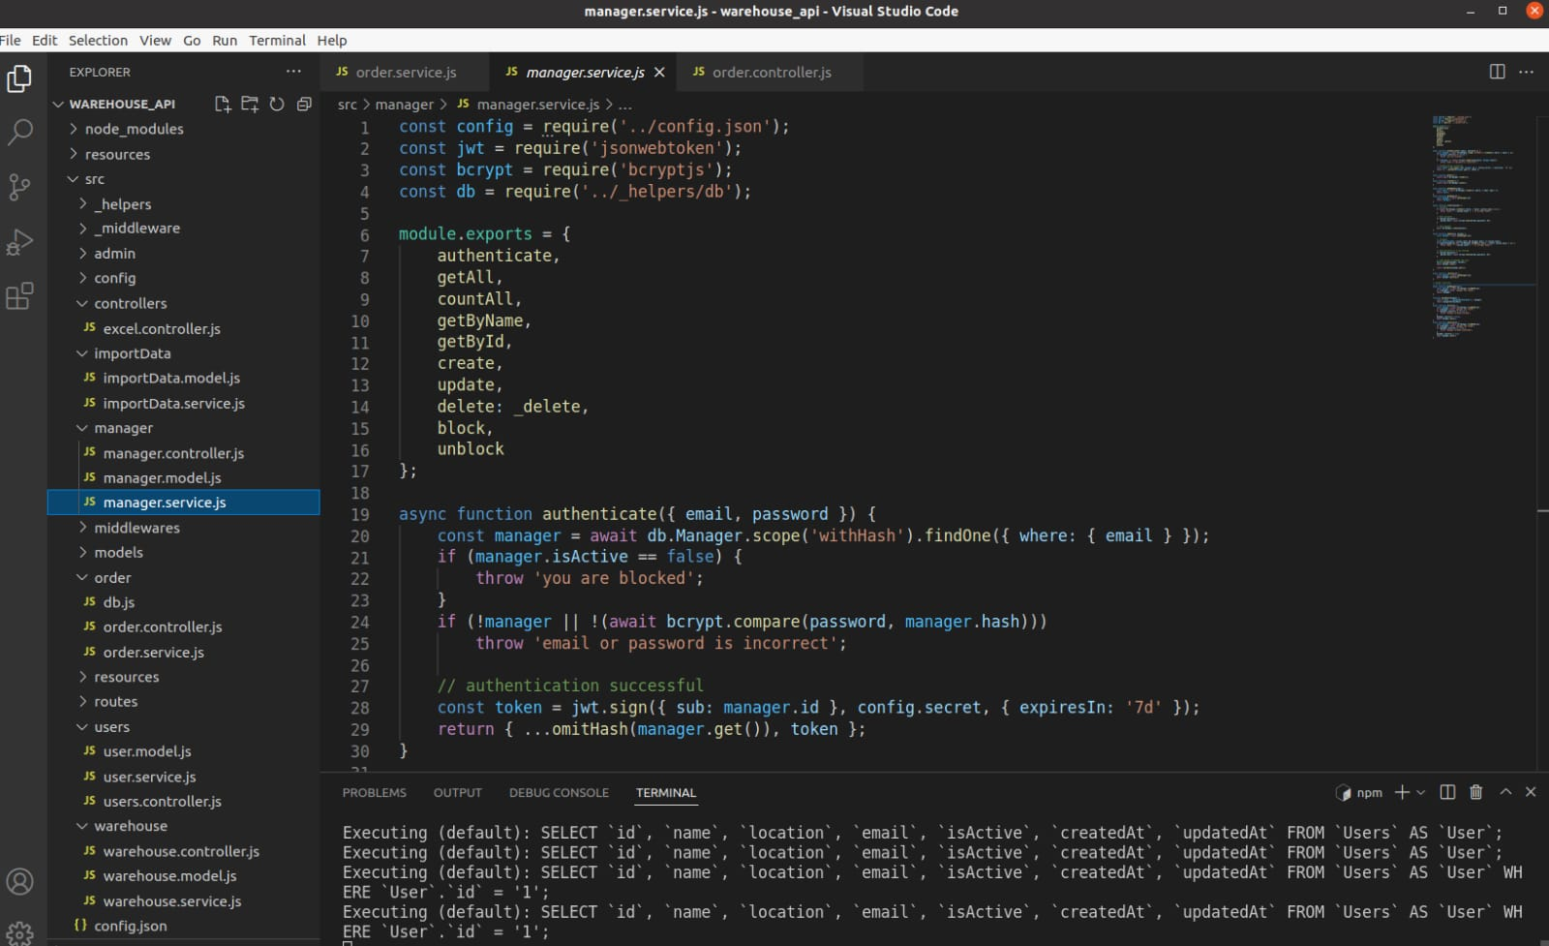

Fig 6.3.1 Folder structure of Project

* API of the admin can create manager and delivery person.

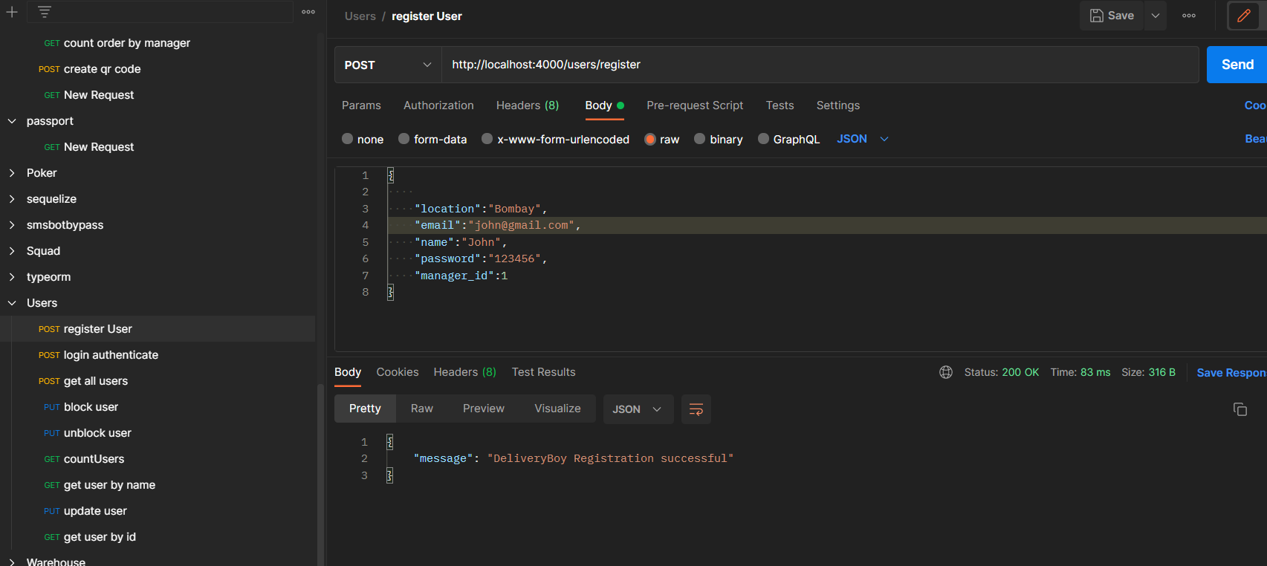

Fig 6.3.2 Admin create manager and delivery boy

* Admin can edit, block-unblock manager and the delivery person.

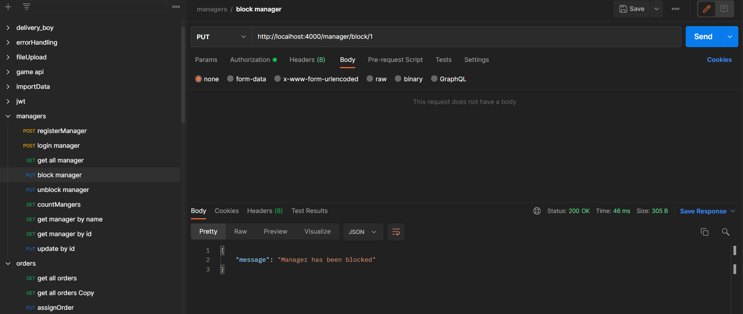

Fig 6.3.3 Admin block manager

* Admin can view list of all manager, delivery person and warehouses.

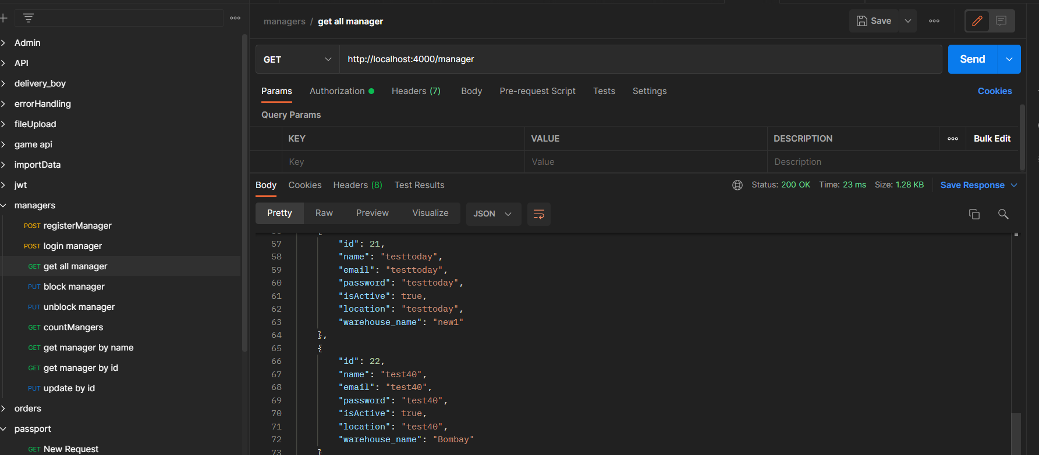

Fig 6.3.4 Admin view list of all managers

* If manager or delivery person are blocked by admin than they can not login.

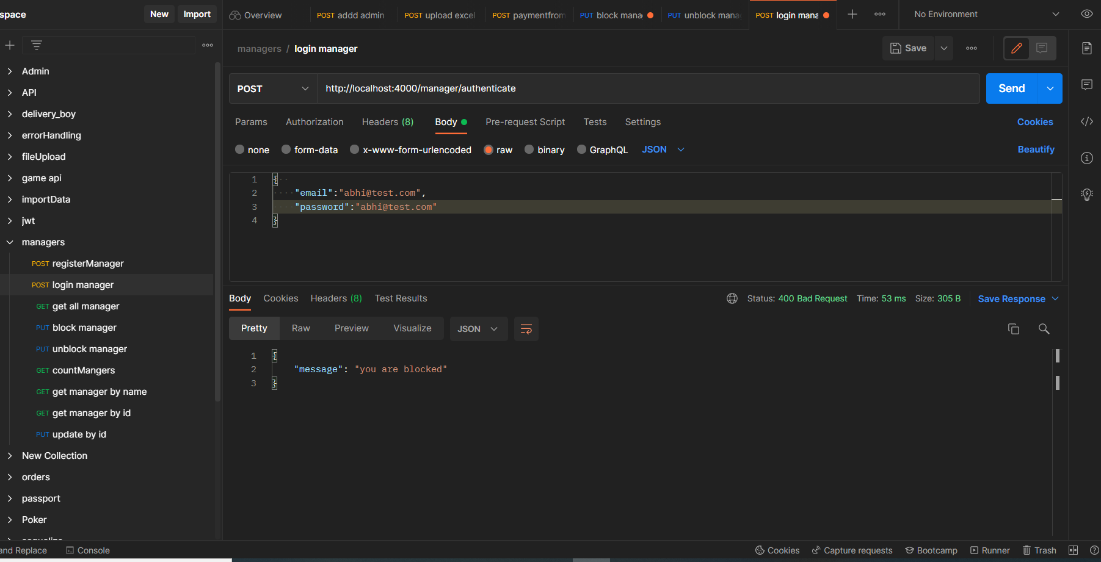

Fig 6.3.5 Manager can not login

* If manager can upload file except the excel file it gives the error.

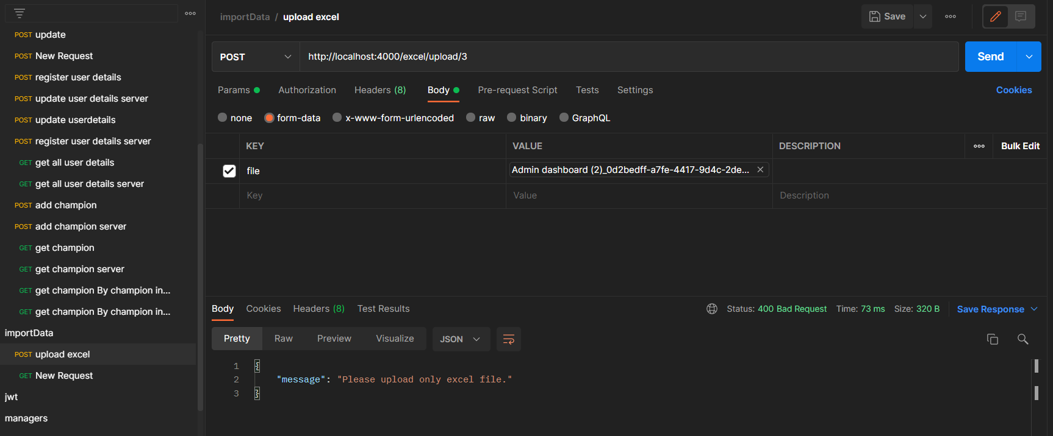

Fig 6.3.6 Upload excel file

* Manager assign order to delivery person.

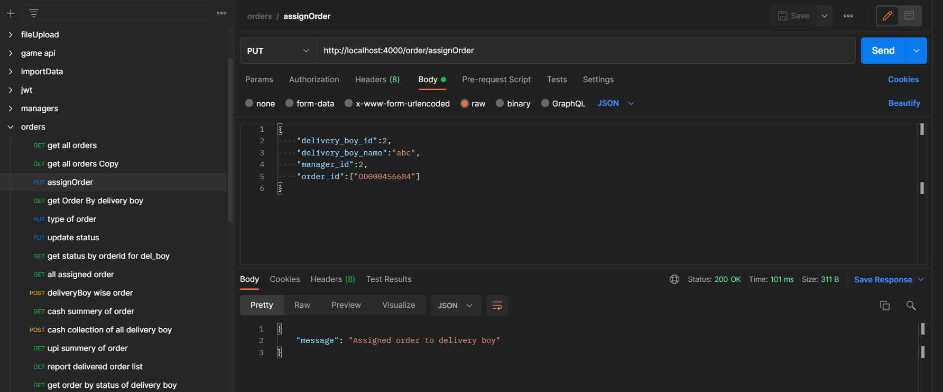

Fig 6.3.7 Manager assign order

* Delivery person can view its order.

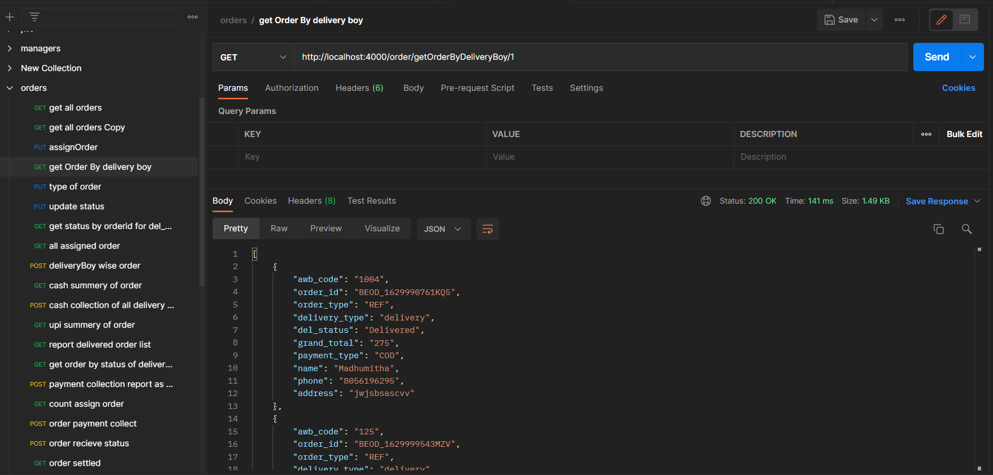

Fig 6.3.8 Order of delivery person

* Delivery person update the status of order which is delivered or cancelled.

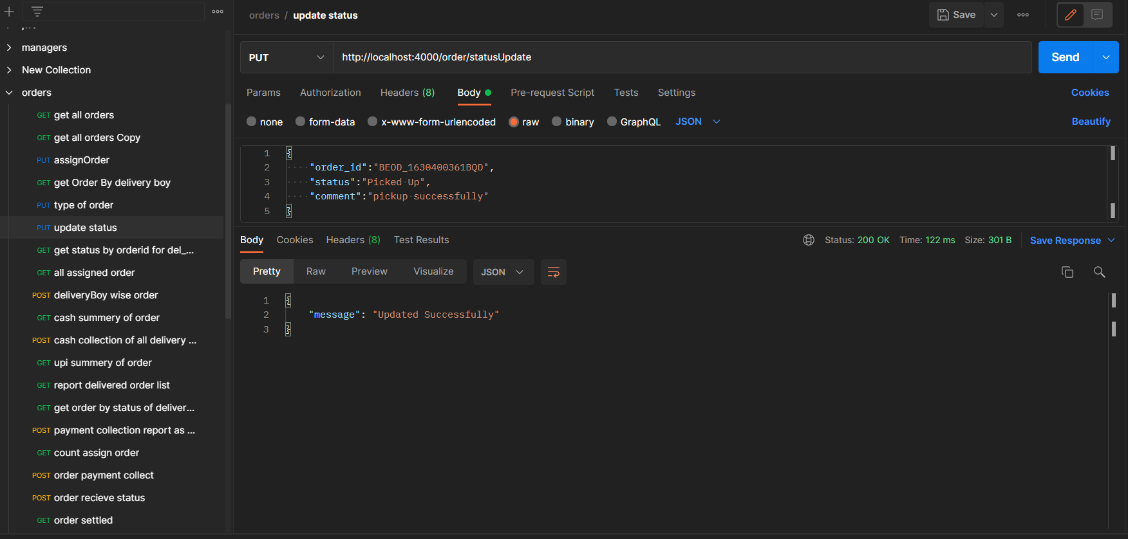

Fig 6.3.9 Update the status of Order

* Admin and Manager can view the orders of particular delivery person by datewise.

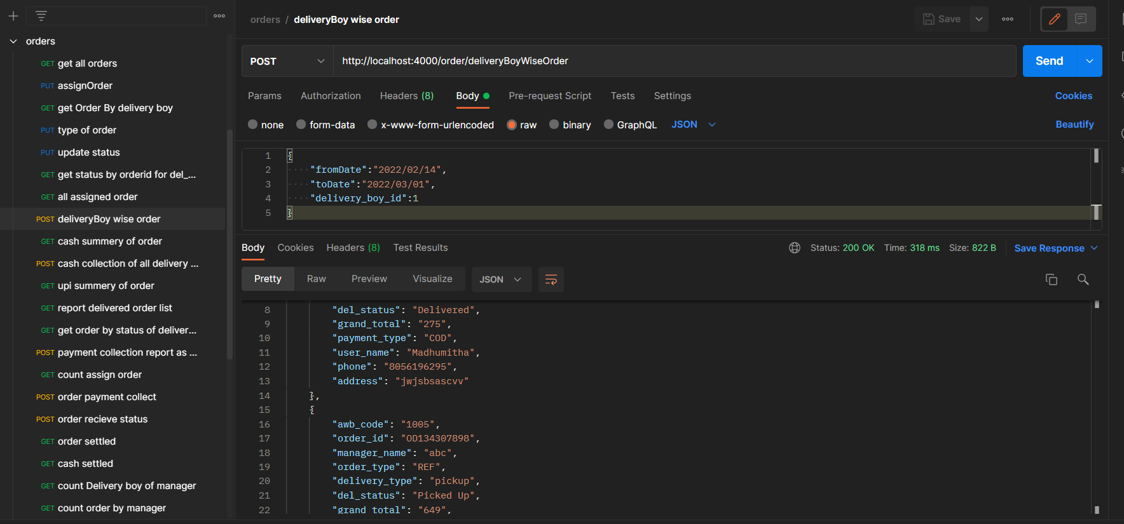

Fig 6.3.10 Delivery person wise order

* Delivery person can see the history of orders which he delivered.

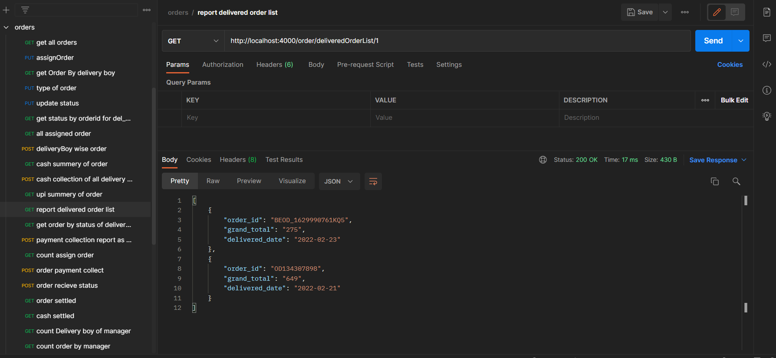

Fig 6.3.11 History of Orders for delivery person

* Admin and manager can view the cash collection report of delivery persons report.

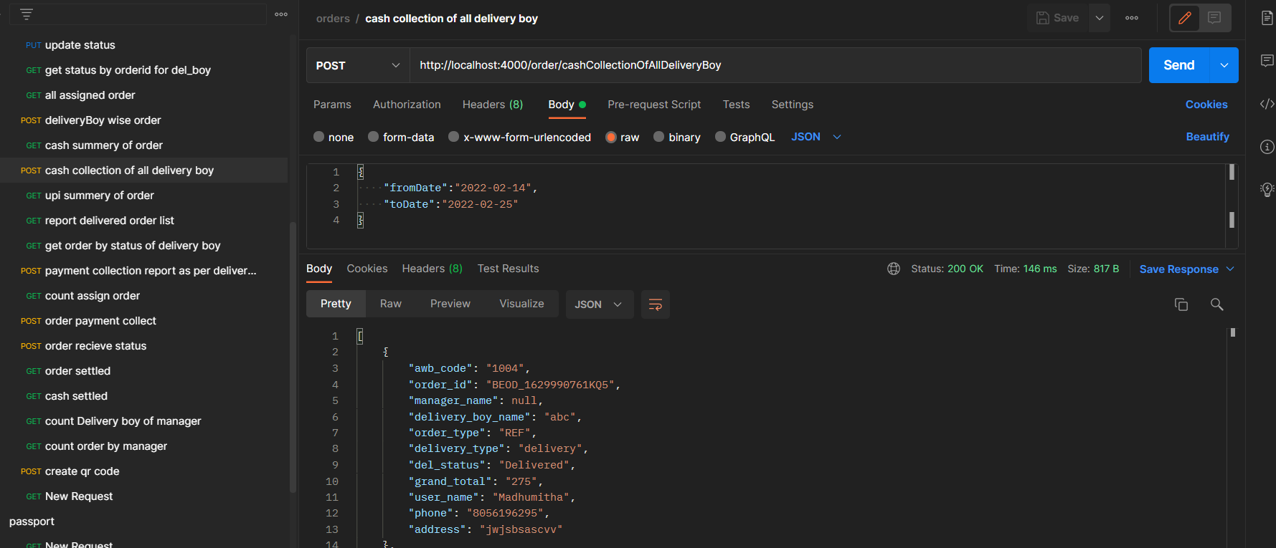

Fig 6.3.12 cash collection of delivery person

* Database

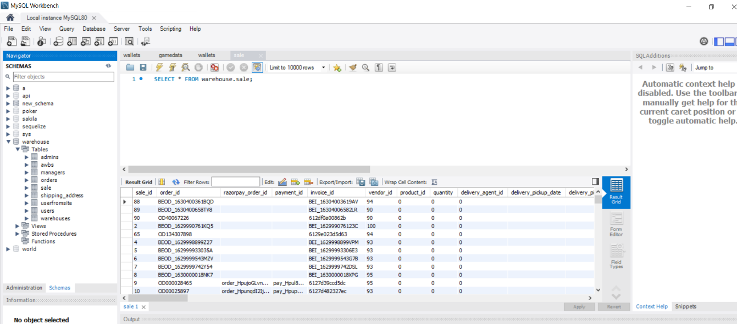

Fig 6.3.13 Database

* Manager and admin can view the reports.

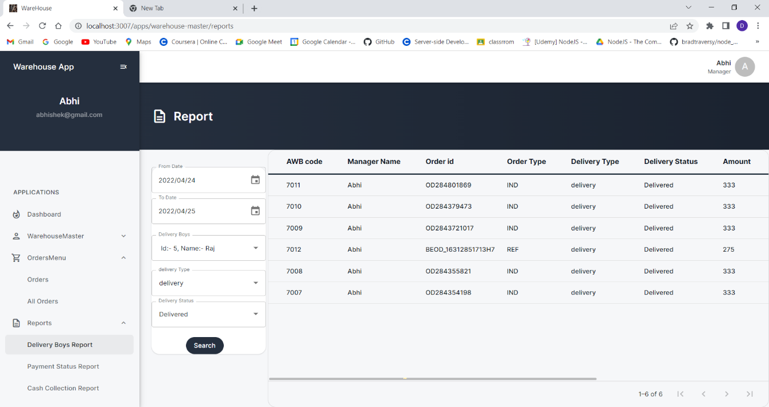

Fig 6.3.14 View the reports

* Project Code

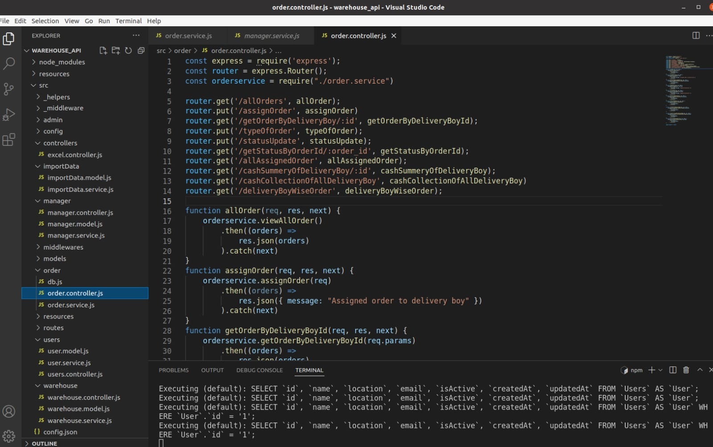

Fig 6.3.15 Project code-1

* Project Code

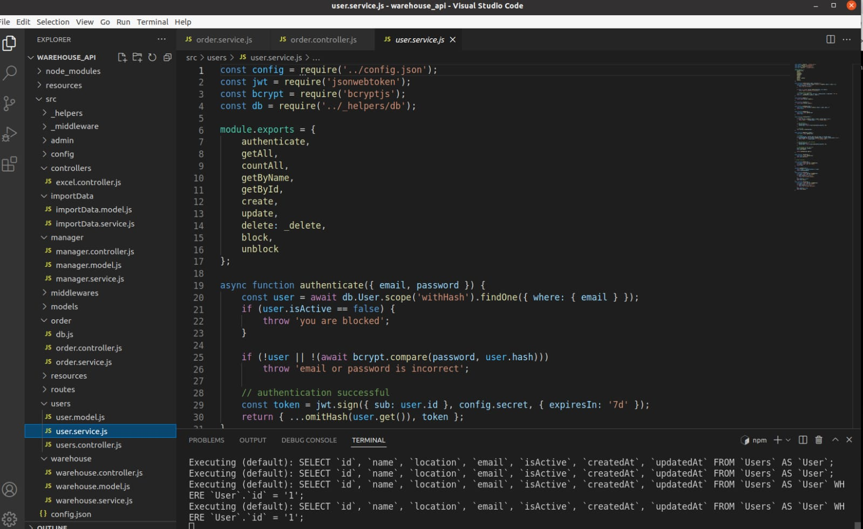

Fig 6.3.16 Project code-2

**Chapter 7: TESTING**

**7.1 TESTING PLAN**

After completely developing each screen, I have been assigned to test each screen for basic functionality working and the design exactly matches the client’s proposed one in each and every possible screen size. Other functionality testing and code review are done by the QA team.

**7.2 TEST RESULT AND ANALYSIS**

**7.2.1 Test Cases**

Table 7.1 Test cases for Superadmin Panel

|  |  |  |  |  |
| --- | --- | --- | --- | --- |
| Test Id | Condition | Expected Output | Actual Output | Remarks |
| T01 | Add Client Form should not go ahead before entering full data in form stepper | The client can be after filling all the required information of the client. | The client is been successfully added after filling all the required information of the client. | None |
| T02 | Add Superadmin, Distributor and Agent | Superadmin should be able to add New Superadmin, Distributor and agent after entering valid required information. | Superadmin is now able to add New Superadmin, Distributor and agent after entering valid required information. | None |

Table 7.2 Test cases for Portal Panel

|  |  |  |  |  |
| --- | --- | --- | --- | --- |
| Test Id | Condition | Expected Output | Actual Output | Remarks |
| T03 | Student digital fees payment | Student should be able to pay fees with available offered discounts. | Student will be able to pay fees with available offered discounts. | Module under development. |
| T04 | Online classes and Homework Submission | Students should be able to join their respective classes through meeting link and also should be able to submit homework. | Students will be able to join their respective classes through meeting link and also should be able to submit homework. | Homework module and meeting module under development due API Server. |

Table 7.3 Test cases for common modules

|  |  |  |  |  |
| --- | --- | --- | --- | --- |
| Test Id | Condition | Expected Output | Actual Output | Remarks |
| T05 | Localization (Internationalization) | Users should be able to use website in their native language beside of English. | Users are able to use website in their native language beside of English. | None |

**CHAPTER - 8 CONCLUSION AND DISCUSSION**

**8.1 OVERALL ANALYSIS OF INTERNSHIP**

During this internship I have learned Back-End development Framework Nodejs and the How MySQL Database Work in Nodejs . I have learned about clean coding standards and clean architecture of the code. I have also learned so many soft skills like better communication and management of work.

**8.2 DATES OF CONTINUOUS EVALUATION**

* Continuous Evaluation 1: 16/02/2022
* Continuous Evaluation 2: 29/03/2022

**8.3 PROBLEMS ENCOUNTERED AND POSSIBLE SOLUTIONS**

The problem encountered in this system was to how to upload the excel file and validate that file. For that I took the help of senior developer and he help me to find the module for this problem and get the solutions.

**8.4 SUMMARY OF INTERNSHIP**

To experience the practical working of what we studied in the book theories, is very interesting, memorable and very important in our education. Doing internship is my first experience of working for any company and learn how the things are being done in the actual industry.

This internship has been an excellent and rewarding experience. During this internship I Learn about the how the projects being develop in the actual industry Also know about the company works and deals with the big clients.

**8.5 LIMITATION AND FUTURE ENHANCEMENT**

Currently, it is only available in the educational domain it can also be available in educational domain. Limited number of API calls can be called, API Management Server is yet to be assigned by Client.

**8.6 REFERENCES**

1. **Angular Calendar:**

<https://www.udemy.com/course/the-complete-nodejs-developer-course-> 2/learn/lecture/13729518#overview

1. **Upload and download excel file in nodejs:**

https://www.bezkoder.com/node-js-upload-excel-file-database/

1. **Form Validation:**

https://www.section.io/engineering-education/how-to-build-authentication-api-with-jwt-token-in-nodejs/

https://sequelize.org/docs/v6/

<https://www.tutorialspoint.com/css/index.htm>

1. **Javascript Reference:**

<https://www.tutorialspoint.com/javascript/index.htm>

1. **Bootstrap Reference:**

[https://getbootstrap.com/docs/5.1/getting-started/introduction/](https://getbootstrap.com/docs/5.1/getting-started/introduction/%20)

**9**. **jQuery Reference:**

[https://www.tutorialspoint.com/jquery/index.htm](https://www.tutorialspoint.com/jquery/index.htm%20)

**10**. **Angular Reference:**

<https://www.w3schools.com/Angular/default.asp>

**11.** **NodeJS:**

<https://www.w3schools.com/nodejs/>

1. **MongoDB:**

<https://www.w3schools.com/nodejs/nodejs_mongodb_create_db.asp>

1. **MySQL:**

<https://www.w3schools.com/mySQl/default.asp>

1. **Sweetalert:**

<https://sweetalert2.github.io/>

1. **Git:**

<https://www.atlassian.com/git>

1. **SourceTree:**

<https://confluence.atlassian.com/get-started-with-sourcetree>

1. **Bitbucket:**

<https://www.atlassian.com/git/tutorials/learn-git-with-bitbucket-cloud>